Graphing Parabolas Quiz /18

1. Graph each function so that it fills the grid. Several points should be clearly marked. Determine the: vertex, equation of the axis of symmetry, y-intercept, x-intercept(s), domain, range, and max/min value.
a) $y={(x-3)}^{2}-4$
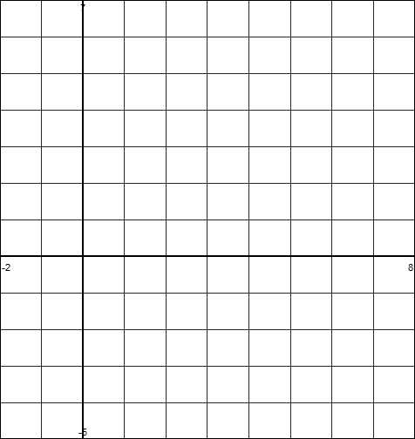

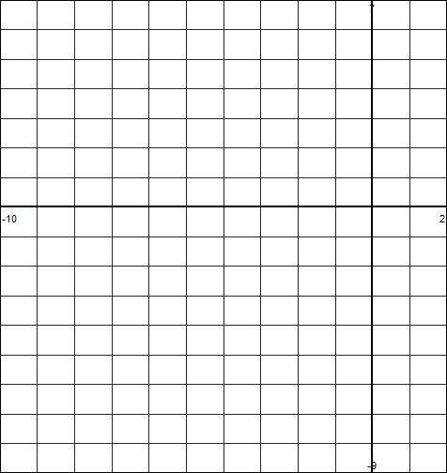
b) $y=-\frac{3}{4}{(x+5)}^{2}+6$

