Quadratic Function Applications /27

1. The side length of a square is 10 cm. Four points on the square are joined to form an inner square, as shown. Find the minimum area of the inner square, in square centimeters. 4 marks

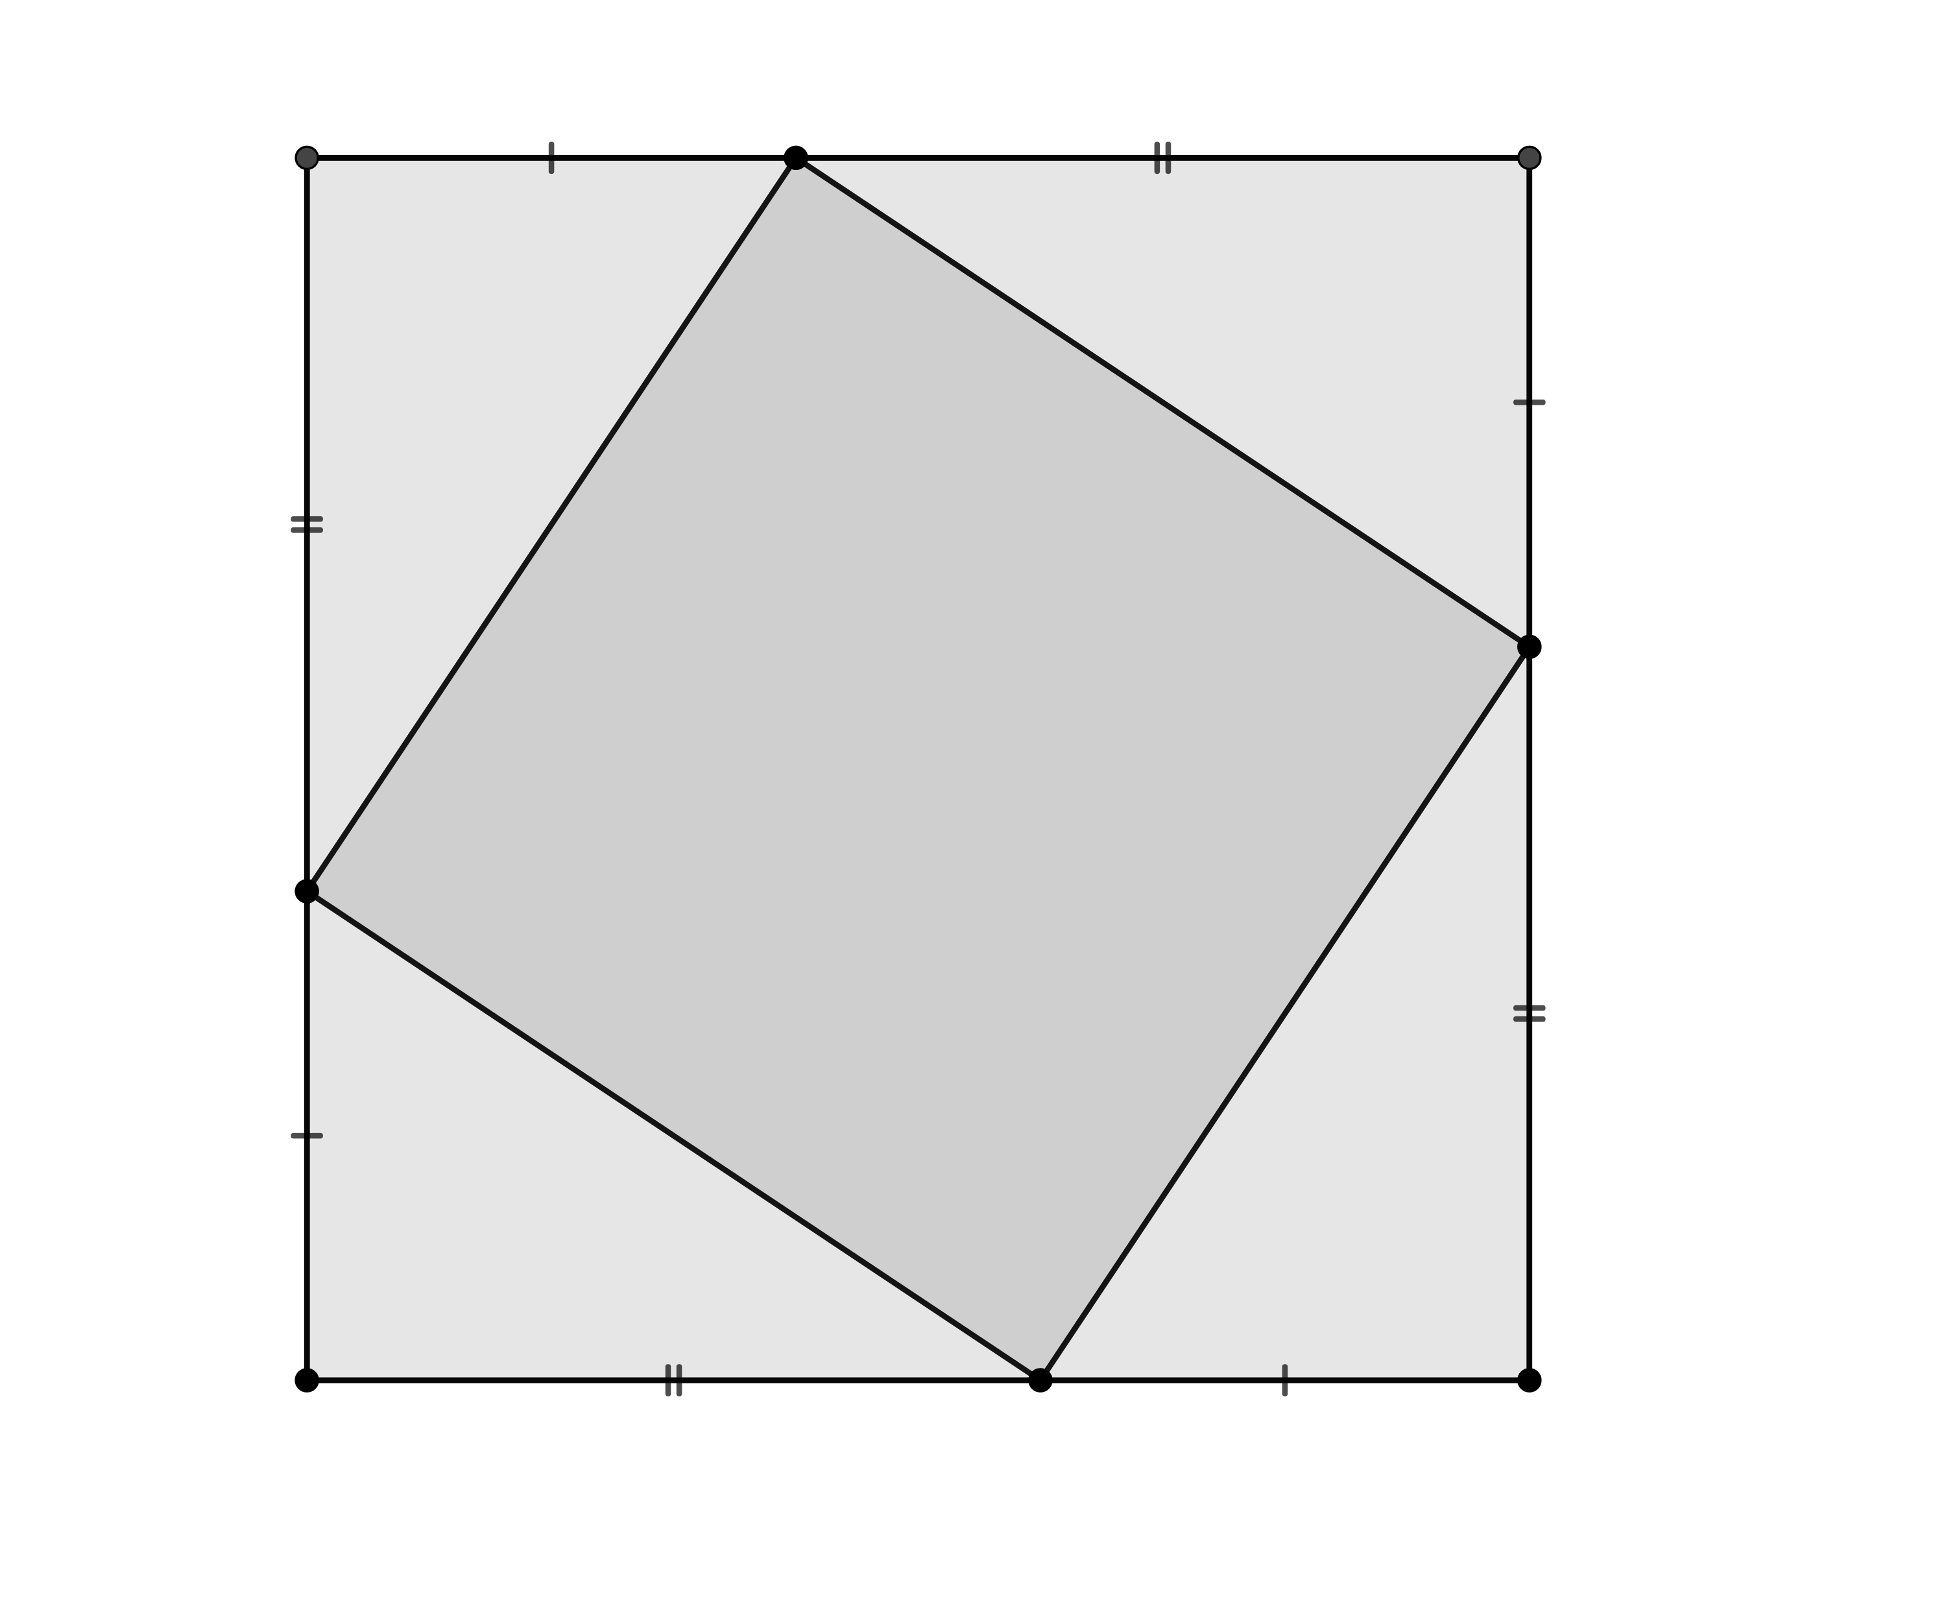

2. The weekly profit of a manufacturer, P hundreds of dollars, is modelled by the equation , where x is the number of units produced per week, in thousands. 3 marks
a) How many units should the manufacturer produce per week to maximize profit?
b) What is the maximum weekly profit?

3. A student is asked to do the following: “Choose any number and square it. Then, subtract eight times the original number. Then, add 35.” 3 marks

- If $x$ is the original number and $y$ is the result, write an equation that represents the instructions.
- Find the original number that gives the least result.

4. Two numbers have a sum of 34. Find the numbers if the sum of their squares is a minimum. 3 marks

5. An amusement park charges $8 admission and averages 2000 visitors per day. A survey shows that, for each $1 increase in admission cost, 100 fewer people would visit the park. Determine both the admission price that gives a maximum revenue and what that maximum revenue would be. 4 marks

6. A cattle farmer wants to build a rectangular fenced enclosure divided into five rectangular pens, as shown in the diagram. A total length of 120 m of fencing material is available. Find the overall dimensions of the enclosure that will make the total area a maximum. 4 marks

7. Wile E. Coyote’s new rocket company (he decided to perfect his system) has found that the revenue from sales of rockets is a function of the unit price p that it charges. If the revenue R is given by 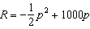, what unit price p should be charged to maximize revenue? What is the maximum revenue? 3 marks

8. In a bowl of cold chili, the amount of bacteria present can be represented by , with , where B(T) is in millions of bacteria, and T is temperature in degrees Celsius. At which temperature will the fewest bacteria be present? How many bacteria will be present? 3 marks

