Slope of a Line
$$m=\frac{rise}{run}=\frac{∆y}{∆x}=\frac{y_{2}-y_{1}}{x_{2}-x_{1}}$$
Linear Relations
Slope Intercept Form | Standard Form | General Form | Point Slope Form | Intercept Form
$$y=mx+b$$ | $$Ax+By=C$$ | $$Ax+By+C=0$$ | $$y-y_{1}=m\left(x-x_{1}\right)$$ | $$\frac{x}{a}+\frac{y}{b}=1$$

Uniform Motion
$$distance=speed×time$$

Arithmetic Sequences and Series
$t_{n}=a+\left(n-1\right)d$ $S_{n}=\frac{n}{2}(a+l)$ $S_{n}=\frac{n}{2}\left[2a+\left(n-1\right)d\right]$

Finance

Simple Interest Compound Interest

$I = P×r×t$ $A= P(1+rt)$ $A=P{\left(1+\frac{r}{n}\right)}^{nt}$

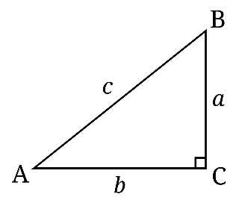
Right Triangles
Primary Trig Ratios Pythagorean Theorem
$\sin{A=\frac{opposite}{hypotenuse}}$ $a^{2}+b^{2}=c^{2}$
$$\cos{A=\frac{adjacent}{hypotenuse}}$$
$$\tan{A}=\frac{opposite}{adjacent}$$

