Transformations Quiz /21
For every function, it is important to always change it to the form $y=af\left(b\left(x-c\right)\right)+d$ before applying any of the transformations. Remember to always reflect, expand, or compress first then translate horizontally or vertically.
- The point $(-6,15)$ is on the graph of $y=f(x)$. What point must be on the following graphs:
6 marks
- $y=2f(x-3)$

- $y=f\left(2\left(x+1\right)\right)-3$

- $3\left(y-4\right)=f(-x+2)$

- $y=-f\left(\frac{1}{2}\left(x+4\right)\right)-3$

- $y=f\left(3x-6\right)+2$

- $y=-\frac{1}{2}f(-2x-10)$

- For each function $f(x)$, write the new simplified function indicated: 3 marks
- $f\left(x\right)=x^{3}+x^{2}$ | - $f\left(x\right)=x^{4}+3$ | - $f\left(x\right)=\frac{x}{x+1}$
- $f(-x)$ | - $f(-x)$ | - $f(-x)$
- $-f(x)$ | - $-f(x)$ | - $-f(x)$
- $-f(-x)$ | - $-f(-x)$ | - $-f(-x)$
For which function above is $f\left(-x\right)=f(x)$? What type of function is this called? 1 mark

- Given the function $f\left(x\right)=\frac{x}{x+1}$, determine the inverse function $f^{-1}(x)$. 3 marks

- Given the graph of the function $y=f(x)$ below, sketch the graph of each new function.
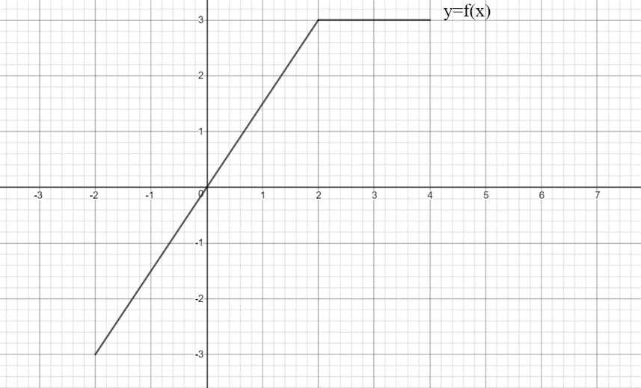

- $y=2f(2x+4)$ 3 marks b) $y=-3f(-\frac{1}{2}\left(x-1\right))$ 5 marks

