1. List the domain and range of each relation. /28
a) 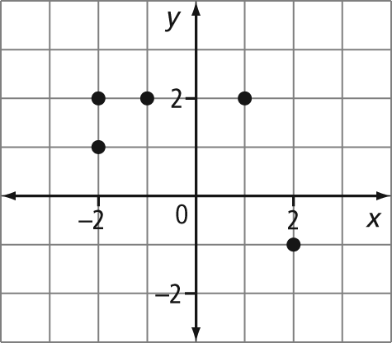

b)
x | y
7 | 3
5 | 2
3 | 1
1 | 0

c) (10, 5), (8, 4), (6, 3), (4, 2), (2, 1)

2. Describe the set of numbers indicated by each number line using words and interval notation.
a) b)

c) d)

3. Represent the set of numbers indicated using a number line.
a) all real numbers less than 5 but greater than or equal to 0

b) (–4, 7]

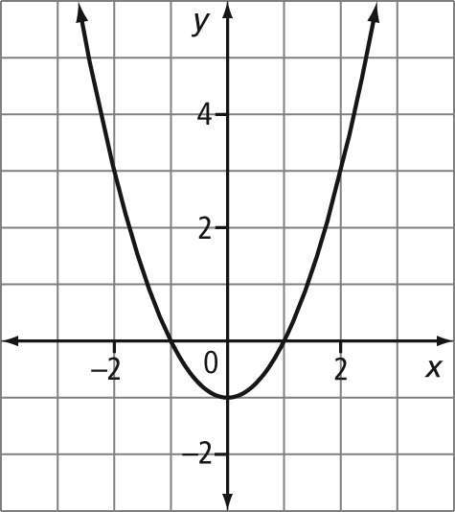
4. Give the domain and range of each graph using words, a number line, interval notation, and set notation.
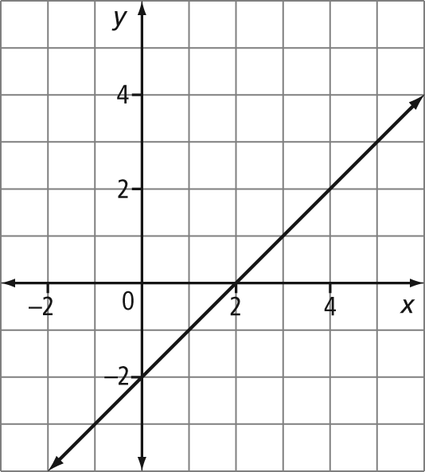
a) b)

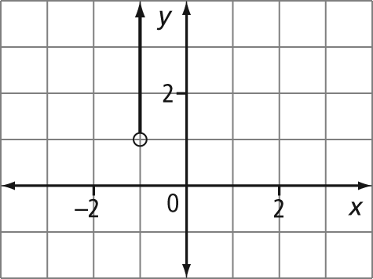
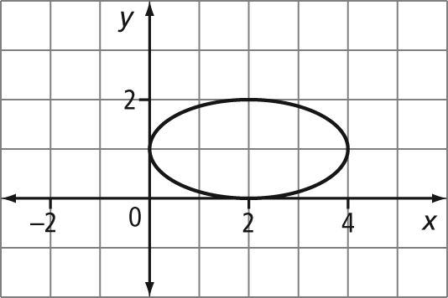
c) d)

