Equations of Parabolas Quiz /16

Determine the equation of each parabola. Be clear about how you are finding your constants.
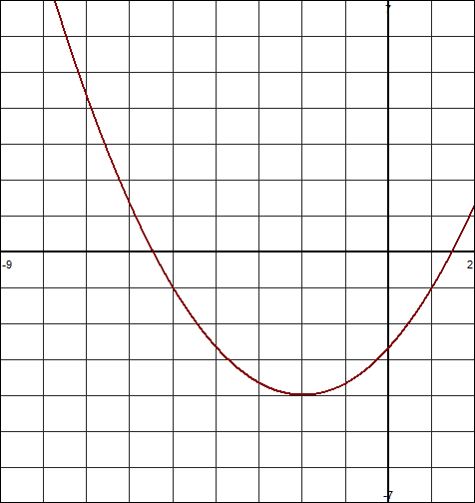

- x-intercepts $-\frac{4}{3}$ and 5 and through (3,52).

- Through the points (-5,1), (-9,1) and (-1,-15).

- Through the points (-6,0), (2,8), and (4,25)

