Graphing Polynomials Quiz /16

1. Determine the equation, in factored form, of the polynomial graphed below. (2 marks)
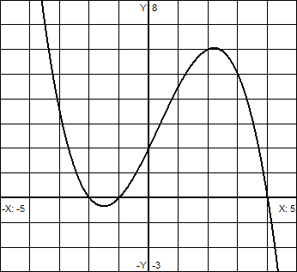

2. Determine the equation, in factored form, of the polynomial graphed below. (2 marks)
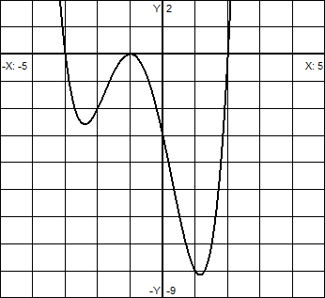

3. From the table of values below, what is the minimum number of zeros possible for the polynomial function P(x). State at what integer, or between what integers, the zeros occur. (3 marks)
x | -5 | -4 | -3 | -2 | -1 | 0 | 1 | 2 | 3 | 4
P(x) | -10 | -6 | 4 | 8 | -3 | -7 | 0 | 8 | 12 | 40

4. Determine the equation, in factored form, of the polynomial of degree 4, that has -2 as a root of
multiplicity 3, and as a factor. You do not need to find the value of a. (2 marks)

5. A polynomial function P(x), of degree 3, has the real zeros -2, 1, and 4, and a y-intercept of -32. Find the value of P(-3). (3 marks)

6. Graph $f\left(x\right)=(x+3){\left(x+1\right)}^{2}(x-2)(x-5)$. All intercepts, min/max points, and end behavior should be clearly seen on the graph. Note y-scale is 50 units. (4 marks)
x | f(x)

