a)  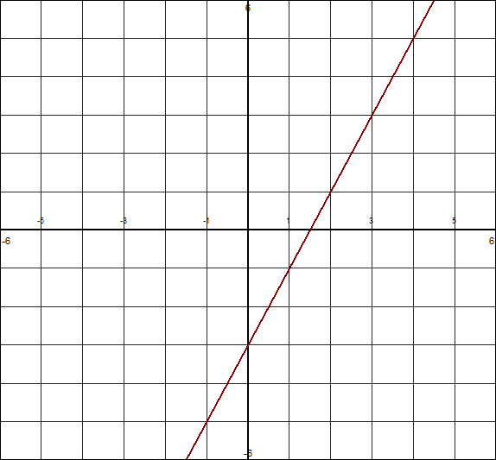 | b)
c)  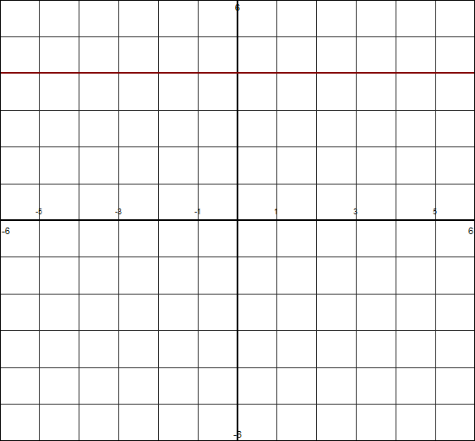 | 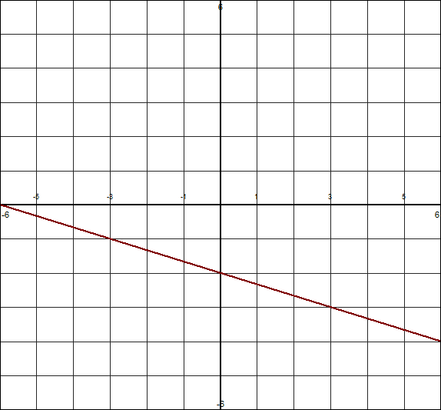  d)
e) (2, 5) and (2, -4) | f) (4, 2) and (-2, 5)
g) (-3, -5) and (-1, -2) | h) (-10, 3) and (7, 3)
1. Determine the slope for each line or pair of points. Show your work. 2 marks each. /22
2. Determine whether the points A(2, 3), B(14, 17) and C(-10, -9) all lie on the same line. Justify your answer. 4 marks

3. The line through the points R(5, 2) and T(9, y) has a slope of 2. What is the value of y? 2 marks

