Graphing Systems /16

1. Solve this system and check your solution. (6 marks)
$y=x^{2}-1$
Check
Solution 1
( , )
Solution 2
( , )
$y=x+1$

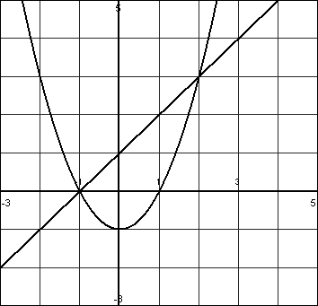

2. Solve each system by graphing. (10 marks)
a) $y=(x+3)^{2}-2$ b) ${y=-\frac{1}{3}(x-1)}^{2}+5$
$y=-x-3$ $y=\frac{1}{2}x^{2}+x-3.5$

(Round to nearest tenth.)

