Trigonometry Word Problems

1. Two airplanes leave an airport, and the angle between their flight paths is . An hour later, one plane has travelled 650 km, and the other has travelled 575 km. How far apart are they?

2. After a windstorm, a tree in Joseph’s backyard was leaning, and he was concerned that it was going to fall. To secure it he attached a strap to the trunk of the tree. The strap was 7 ft. long and attached to the ground 5 ft. from the base of the tree and 3 ft. up the trunk of the tree. What is the angle the strap makes with the tree trunk?

3. A bike race follows a triangular path. The legs of the race are, in order, 5.7 km, 7.5 km, and 4 km in distance. Find the angle between the first leg and the last leg of the race, to the nearest degree.

4. A fire ranger sits in a 20 m tall tower in the woods. From his tower, he sees a fire burning at an angle of depression of . On a bearing of from the first fire he sees a second fire burning at an angle of depression of . Find the distance between the two fires.

5. Lifeguard Jim is sitting on his chair (marked by the square). He suddenly sees a victim (marked by the x) to his left. His immediate distance is 12 m from the victim, but he must swim 40 m in the opposite direction in order to counter the rip-tide which will drag him 35 m to his victim.

Find the angle at which he must enter the water in order to reach his victim using the Law of Cosines. Diagram is not to scale.
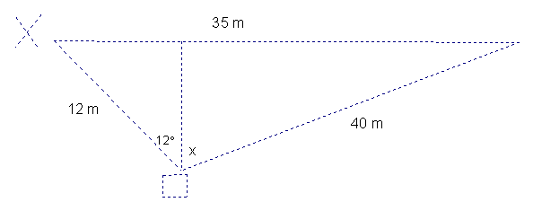

6. Two firefighters want to rescue a cat stuck in a tree. The cat is at an angle of elevation of 38° with respect to one firefighter and 80° with respect to the other firefighter. The firefighters are 30 m apart, and on opposite sides of the tree. To the nearest tenth of a metre, how high off the ground is the cat? Explain your strategy.

7. Two divers are 50 m apart. Each diver sees a treasure chest on the sea floor. From the divers, the angles of depression to the treasure chest are 35° and 51°. To the nearest metre, how far is the treasure chest from each diver? Consider possible cases (i.e. there is more than 1 answer) and show your work.

8. A pair of campers paddle a canoe 3.5 km bearing 295⁰. They then change their direction so they are heading [S35⁰E] and paddle a further 2.7 km. To the nearest tenth of a kilometre, what is the straight-line distance from their end point to their start point? To the nearest degree, in what direction should they head in order to get back to their start point? Show your work.

